Write a pig script to find the count of each Hashtag in the dataset. You can download the twitter data from the below link

**Pig commands**

**LOGIC: got** every line as a input and then used tokenize and flatten and filter by hashtags and made a count

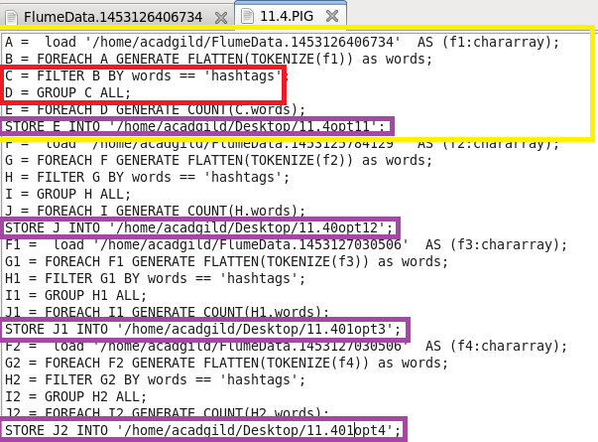

RUNNING PIG

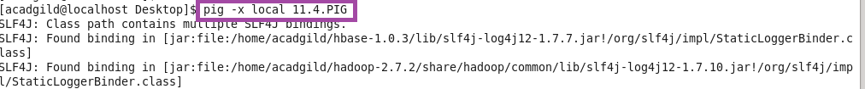

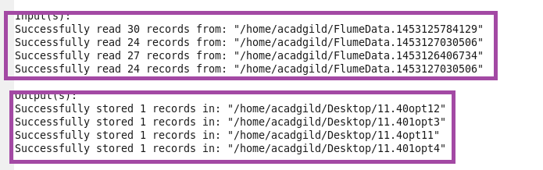

**Output**

